Final Exam Study Guide

## Description

As indicated in class the goal of the exam is to encourage you to review the course material. This study guide is not guaranteed to be comprehensive, **just because some subject is not on the guide doesn’t mean that material is not on the exam**. The sample questions are representative of the questions to be asked. (These are actually, perhaps, a little more ambiguous and take longer to answer. The real exam questions are quicker to answer). The slides and the assigned readings in Forsyth and Ponce are considered the material that can be in the final exam.

Please add to!

## Questions Digest

The questions/notes below are representative of content that will be covered by the exam.

1. LINEAR SYSTEMS  
   1. Make sure you understand what makes certain image operations linear and what are some operators we use in, say edge detection, that are not linear.

Video: [2A-L3 > https://docs.google.com/document/d/10IHaTQZurgztOYdK3coejhJdIbDELhTEeyqO-FiWu4Y/edit#1. Intro](https://youtu.be/QF2EZBfzzl8?t=38)

In order to be linear, operator H must have 2 properties:

1. Additivity (things sum) H(f1+f2) = H(f1) + H(f2) distributive property.
2. Multiplicative scaling (Homogeneity of degree 1) H(a*f1) = a*H(f1)   
   “a” is a constant

This comes into play when using filters which allows for nice tricks like applying impulse kernels. See 2A-L3. Ex: Median, Maximums and Square roots != linear operations.

Examples for linear fns: **Sum, Average, Division, Derivative**

Examples for non-linear fns: **sqr root, max**, **median**

* 1. Describe how you might do edge detection using at least two operations – first a linear one followed by some number of non-linear ones – that would find edges in a slightly noisy image.  
     A sobel operator is a linear operator that can be used to detect edges (due to finding areas of rapid change in pixel intensity). A non-linear filter (much like the median filter) can then be used afterwards to remove “insignificant” edges or false positives due to the appearance of noise.

Edge detection steps which’

\

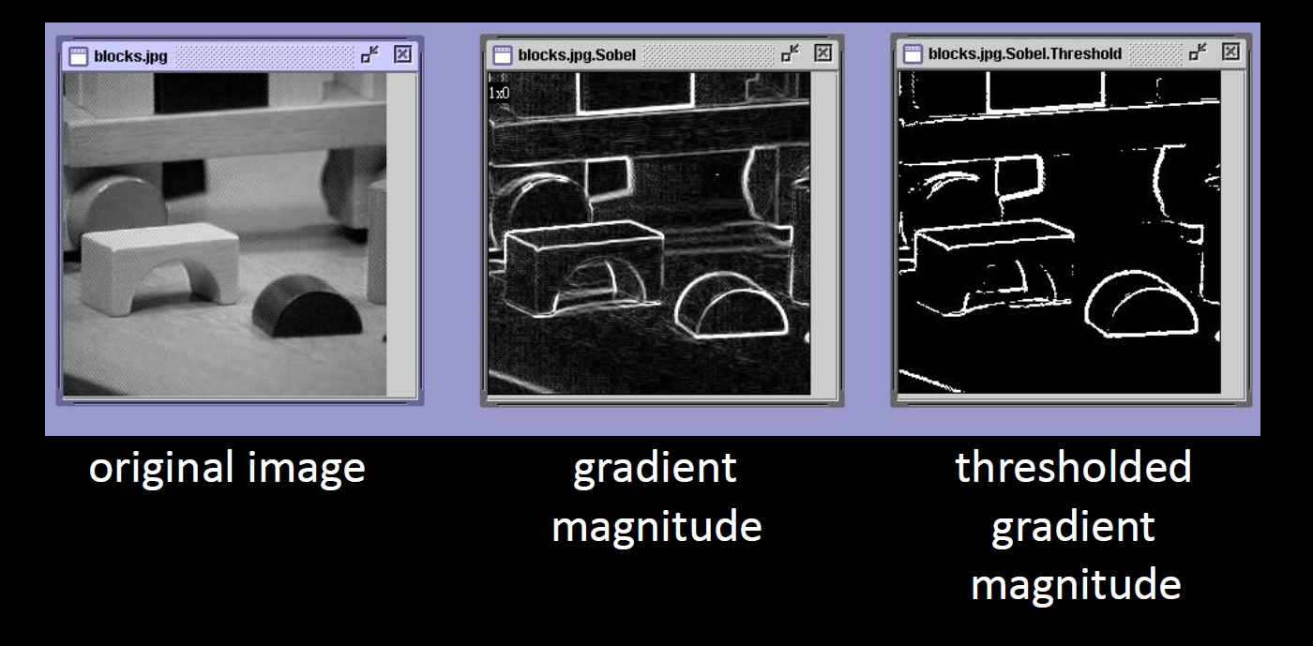

* 1. What’s the difference between Gaussian noise and salt and pepper noise? Why does a linear filter work well to reduce the noise for the Gaussian case but not the other?

Gaussian noise is normally distributed (with mean 0) random noise added to an image while salt and pepper noise is basically randomly picking pixels from an image and setting them to black (0) or white (255).

**Linear filter works well for Gaussian noise** because it often involves averaging pixel values over certain region which even out the Gaussian noise (since they have mean 0), it does not work for salt and pepper noise since changing pixels to 0 and 255 will in most cases apply noise to image that do not have average 0. For **salt and pepper noise, median filter** is often recommended.

* 1. How is sharpening done using filtering? And would it matter whether you used convolution or correlation?

Sharpening can be done w/ a linear filter. (Ex: gaussian etc.) 2A-L3

[Double the value then subtract the blurred image]

-You subtract off a blurry version of the original image to get a sharper image

Ex: 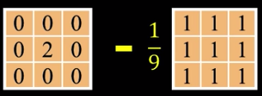. Convolution is correlation with filter rotated 180 degrees (flipped up down and left right), so in this case since the filter is symmetric it does not make a difference.

* 1. What are two ways to compute gradients in an image that has some noise in it?

-Smooth image then take derivative then apply operator to derivative

-Smooth the operator then take the derivative of operator, then apply smoothed derivative to image (both are equal) (faster)

Gradient detectors look for sharp changes in pixel intensities and ID these regions as ‘edges’. 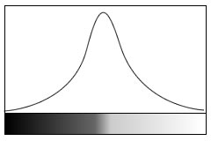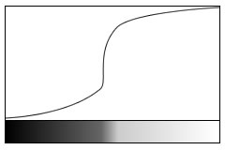

1. Sobel operator:

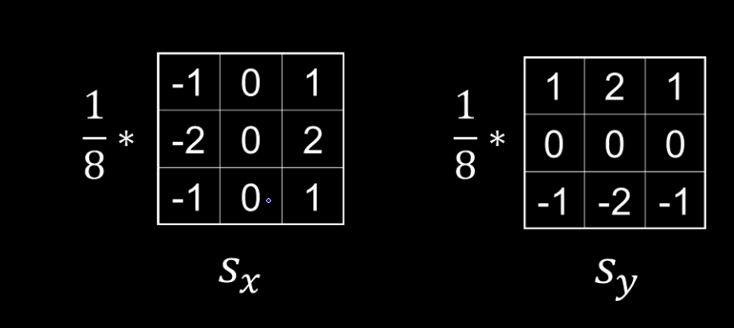

2. Canny edge operator

* Filter the image with derivative of gaussian ← This is to smooth the image
* Magnitude and orientation of gradient
* Non-maximum suppression to thin the edges
* Used high threshold to start edge curves and low threshold to continue them

Non gradient detectors (**should this be here at all ? Needs expansion. Thanks**):

Laplacian operator. By contrast these work by using derivatives of intensity to detect when values cross zero. This will avoid the picking of a specific threshold that is needed in gradient based edge detectors. 2nd order Ex:

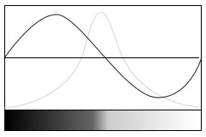

* 1. What can you do during edge detection to account for the fact that some edges vary in contrast along the edge – that is sometimes they are strong and sometimes weak.   
     -One could apply “thinning” (non-maximal suppression) which finds the maximum gradient in a thick line, which turns it into a thin line

-Apply hysteresis to help add back in some thinned edges (Lesson 7.6) by selecting strong edges and connect them via weaker edges (high low threshold params)

1. DATA STRUCTURES
2. 1. A standard Hough transform performs voting for a parametric shape. Why are we doing voting and why does it work?

Voting is done to ensure noise is accounted for. Often when using Hough transform (ex: for line detection) we will see results that somewhat resemble our target but are not strong matches. Voting will ensure the best matches persist since they will have a higher number of votes. Noise votes will be sparse and will likely not accumulate a high score.

* 1. How can the Hough transform help in identifying lines, circles, and other shapes. You should be able to interpret a Hough Accumulator and determine what shapes are present along with details of each one (location, orientation, size, etc.)

-Accumulator array contains the votes

For a line the accumulator is a 2D matrix:

-x axis is theta

-y axis is d (distance from origin)

For other geometric shapes the parameters are different and you might end up with the cones, like below:

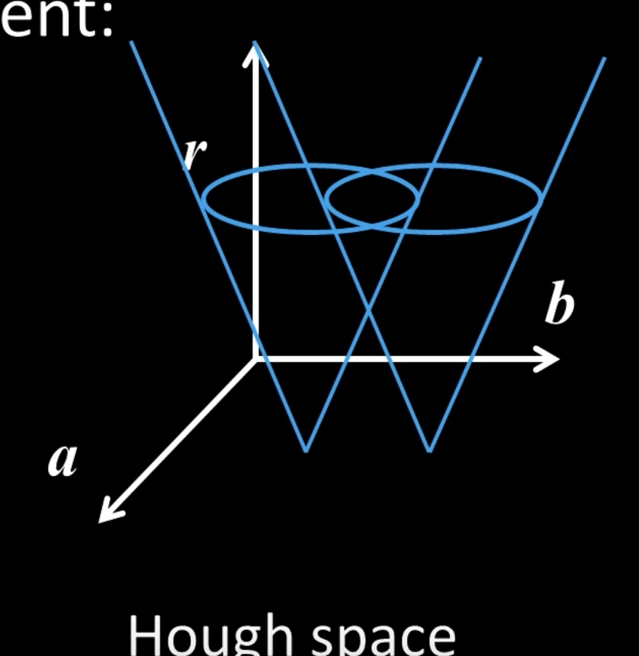

The voting will function the same conceptually as for the simpler line example.

You have points in an image vote based off the factors for a feature you are trying to identify and then you can find the best match for each feature you are trying to find by using local maxima. Points in hough space are lines in image space. Points in image space are lines (or other shapes) in hough space. Brightest points of intersections of houghspace are the lines in image space.

* 1. A friend needs to find the pool balls in an image of a pool table. Would a Hough transform be a good idea? Why/why not? Would RANSAC be better?

Hough transform would be a good idea (better than RANSAC), as we could use the pool balls as a template to match against. RANSAC performs better when used to align two images etc. and does not fit the purpose of this problem.

EDIT --RANSAC would be an ok fit as well if you use a template slightly larger than the ball**!**

With RANSAC you can determine how many points (s) of interest you have (in this case one, which is the center of the ball) and find other features in the image that tells you how accurate is the match between the template and the ball.

Regarding Hough, it would be better because you don’t need a template for the balls. They are circular, and we already know how to search for circular shapes with hough.

EDIT II -- RANSAC does not necessarily have to be used for image matching (in fact, it was originally used for line fitting). Theoretically, you could use RANSAC to fit a circle from a set of points just like you would from the Hough transform. The putative matches would be the points corresponding to the circle, and the matching function would be a circle-fitting algorithm. However, because it uses a random subset, it may be more prone to noise to the Hough transform, even though it takes less space.

1. FREQUENCY  
   1. Fourier analysis decomposes images according to a basis set. What is that basis set?   
      In general, a basis is a linearly independent but not necessarily orthogonal set of vectors that spans the space. (Linearly independent meaning if you draw these vectors out in space they will never collide (think X axis, Y axis, Z axis) beyond the origin). ‘Spans the space’ meaning if you were to think of all such vectors that cover this area you would have a plane representing that ‘space’ (ex: X plane, Y plane, etc..

For Fourier, the basis is a set of vertical and horizontal sinusoids of increasing frequency that describe the periodic elements of the image. The space is “frequency space”.

* 1. How does the Fourier transform encode the magnitude and phase of sinusoidal component of a signal?  
     It uses complex numbers. The amplitude is the square root of the sum of the real and imaginary squares: sqrt(R(w)^2 + I(w)^2). The phase is the arctangent of the imaginary over the real: atan-1(I(w)/R(w))
  2. Is the Fourier transform a linear operation? Why or why not?

Yes. This is because the decomposition of a fourier transform is linear. Ex: For fourier transforms F(f) and F(g) => F(af+bg) = aF(f) + bF(g) (Forsyth pg 120)

* 1. Why does convolving an image with a Gaussian ***attenuate***  (aka lower/diminish) the high frequencies?   
     - the Fourier transform (FT) of a Gaussian is also a Gaussian (2L - 2C)

- the FT of a convolution is a product.

Thus the FT of the convolution of an image with a Gaussian is the product of the FT of this image with a Gaussian, which has its higher frequencies multiplied by a small number (exponential of a big negative number).

**Alternative Answer: Gaussian is just a low pass filter in the frequency domain. Multiplying a signal by an LPF will remove the high frequencies.**

Dumb Answer: The high frequencies usually represent edges in the image and as we know the Gaussian blur soften the edges of the image. YEAH!

* 1. What is aliasing and when does it happen? Draw a picture that explains it in terms of a comb filter doing the sampling and the effect of that operation in the frequency domain.   
     Aliasing occurs when a signal is sampled at a frequency below 2 * the maximum frequency of the signal. (The Nyquist frequency) This causes the samples to appear to describe lower frequency signals. In other words, frequencies that didn’t appear in the original signal “hide” inside the samples.

From 2c-L3:

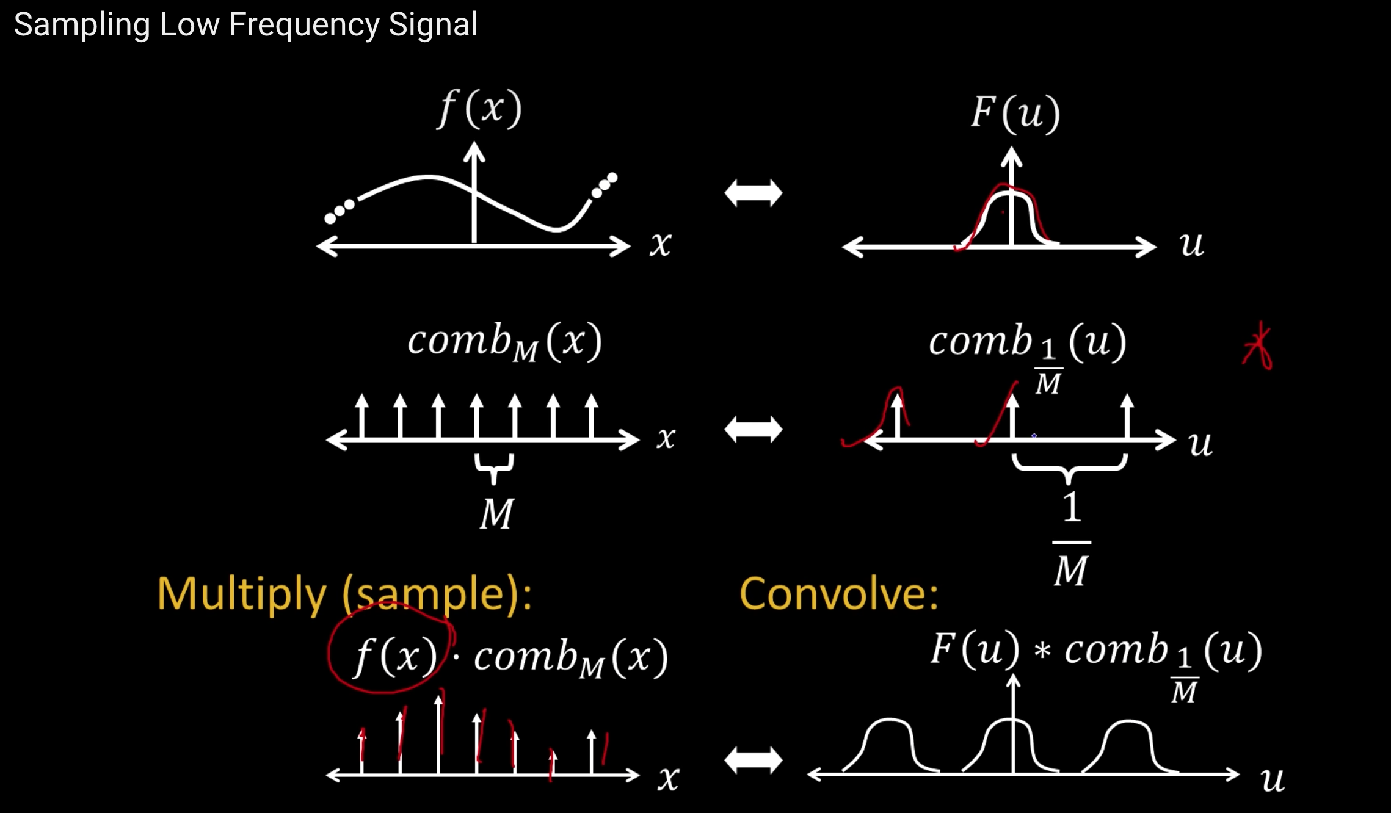

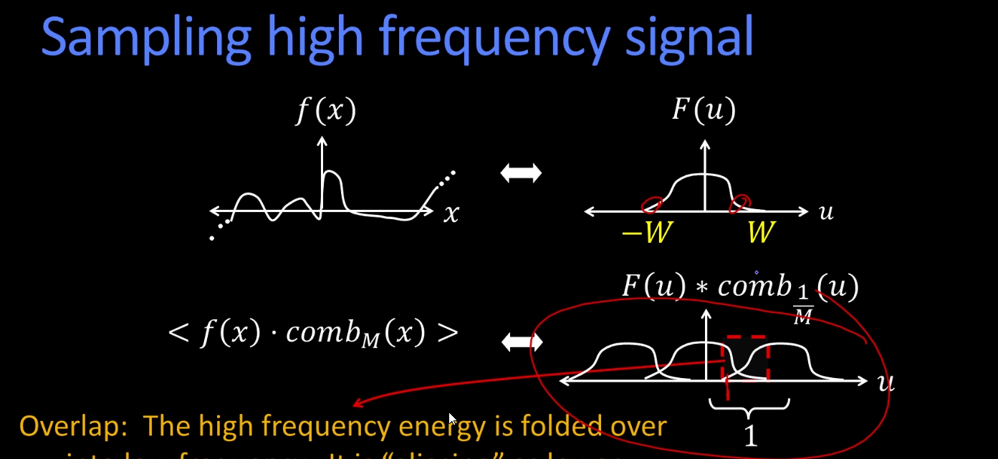

* 1. What is the relation between a Gaussian pyramid and aliasing? In particular, why can you reduce the size at each step and not lose (hardly) any information?

6B-L3, 2C-L3(11) you smooth (low pass filter) the image before subsampling at every level of the pyramid. This removes some of the high frequencies that would cause aliasing when subsampled.

1. CAMERA MODELS and CALIBRATION

Quizzes in 3A-L1 cover calculations on camera models, focal length, etc.

* 1. What is the role of an “aperture” in a typical camera? Why would you want a large aperture? Why would you want a small one?  
     The aperture allows you to capture only a limited amount of light from the scene into the camera. Without an aperture, a single point in an image would appear on the camera film all over instead of only in a particular point on the film. A larger aperture will lead to an image which is not as crisp, but an aperture which is too small will also create a blurry picture due to diffraction. The best aperture size is dependant on the desired depth of field. 3A-L1-4,5, and 10 (Szeliski pg 70)
  2. Related: How is depth of field related to aperture size?

Depth of field refers to how much of a scene is in focus in front of and behind the focal point along the axis between the focal point and the camera. With a large aperture the light rays which are being detected by the camera will diverge faster the further another point in the scene is from the focal point. With a smaller/tighter aperture there would be less divergence of the light rays for a point the same distance away from the focal point. 3A-L1-5 and 10  
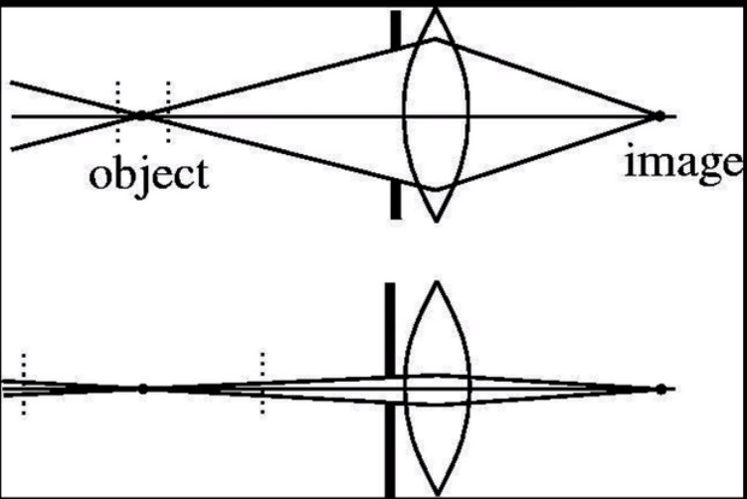

-Small aperture is good for a wide field of depth (landscape photos)

-Large aperture is good for portraits (close up image and background out of focus)

* 1. Zooming the lens (changing the focal length) is not the same as moving closer with the camera. Why?  
     OR: Why does a person’s nose look so big compared to their face if you take an image closer to them than further away?  
     Moving closer to an object introduces more perspective distortion, so an object will not appear as “square”/weak perspective as if you were standing further away and zooming in. A person’s nose would appear bigger in a photo if you are standing very close to them because of perspective distortion. To make the nose appear normal you would want to stand further away and zoom in to remove the perspective distortion. 3A - L1 - 13 and 14
  2. Perspective projection: A point in 3D at location <X,Y,Z> in the cameras coordinate system appears where in the image? And, what assumptions about the intrinsics did you just make?  
     (X,Y,Z) in the camera’s coordinate system would be (-d X/Z, -d Y/Z, -d) in the image. d is the depth from the Center of Projection (COP) to the image plane along the z axis. *If I understand correctly, d is the same thing as the focal length.* For the intrinsics (intrinsics cover 3d camera coords to 2d image coords, extrinsics cover 3d world coords to 3d camera coordsl) we assume the COP is at the origin while staying with a right-handed coordinate system where the z axis or depth is negative in the direction towards the object being captured. 3A - L2 - 3 (Forsyth pg 6)
  3. Why do all lines parallel to each other converge to the same point in an image?

Vanishing points! As you look farther into space it must be the case that all angles reach an infinitely small point (the vanishing point).

Follow the vectors for when t == infinity. x = x0 + at, y = y0 + bt, z = z0 + ct for vec abc. Projection is x' = f(x+at)/z+ct, f(y+bt)/z+ct. when t->inf, x' = fa/c, y'=fb/c.

ALSO note that parallel lines at the same z level (or where z isn't varying) "parallel to the image plane" will not converge.

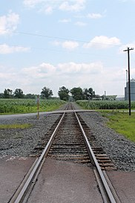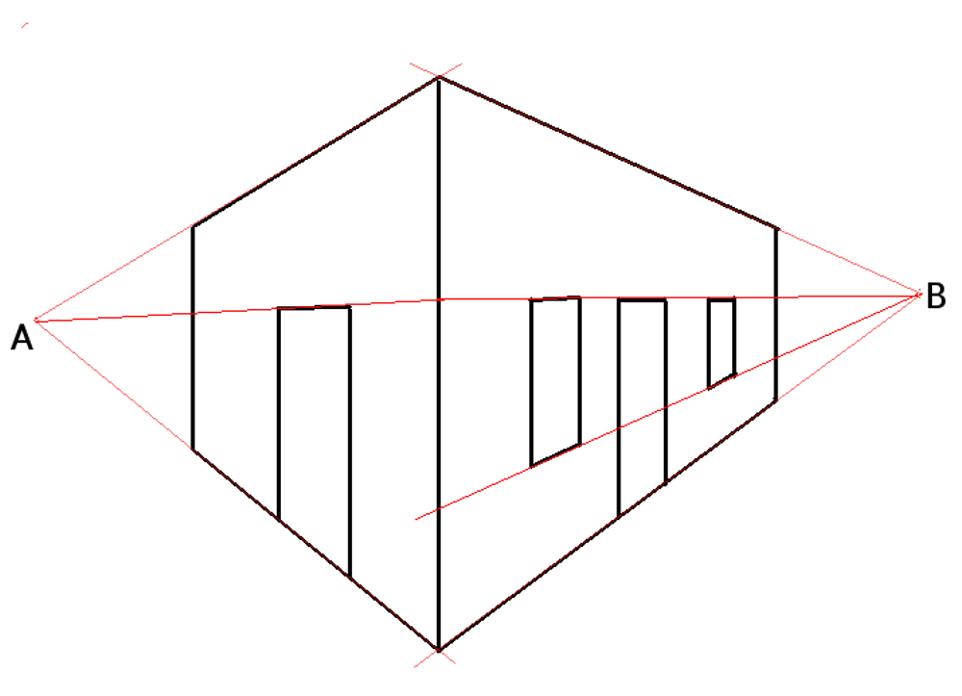

* 1. How many degrees of freedom are in the extrinsics and intrinsics? What are they?

Extrinsic: 3-d world coords to camera 3-d coordinate system thus, total 6 df

Intrinsics: from 3-d camera frame to the 2d image plane thus total 5 df

Extrinsic - There are 6 degrees of freedom in a rigid body (3DOF from fixed one point (X, Y, Z), 2DOF from distance constraint, 1 DOF from rotation around line)

Intrinsic - 5 DOF (focal length, pixel x size, pixel y size, two offsets, and a skew… but

the focal length multiplies the pixel sizes, so those three numbers only count as 2

DOF) - 3C-L2, lesson 4

* 1. How many 3D points need to be observed to do absolute calibration? Why?

6 because you have 12 or 11 unknowns when using either direct linear calibration - homogeneous or direct linear calibration - inhomogeneous respectively.

Dumb answer: 6 because you have 11 unknowns (intrinsic+extrinsic DOF)

* 1. Write the perspective projection equation as a 3x1 = [3x4] * [4x1] How many unknowns are in the above equation?

4 unknowns x, y, z, and f

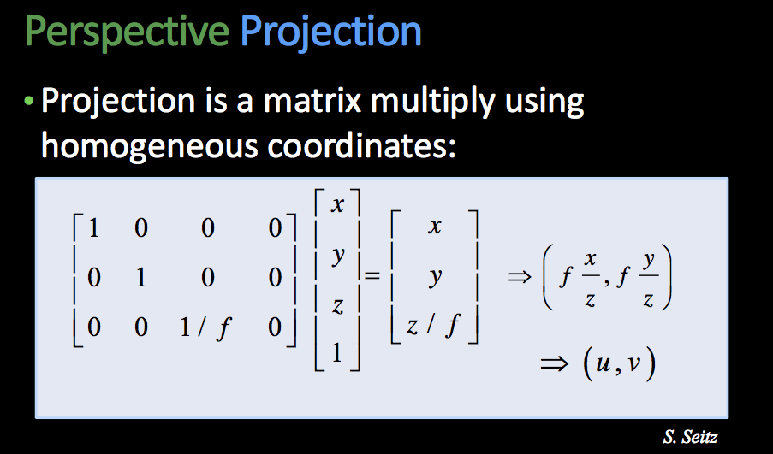

* 1. One way to solve for the unknowns is to view some points whose 3D position is known and whose 2D position is recorded. How many equations do I get per viewed world point? If I have, say, 10 points, how would I solve for those unknowns.

You get 2 equations per point. So with 10 points you would have a total of 20 equations that can be solved by using SVD with direct linear calibration - homogeneous or with direct linear calibration - inhomogenous.

1. N-VIEWS  
   1. What is an affine transform? And how many pairs of matching points between two images do I need to solve for it?  
      - Basically the warping of an image (combining linear transform + translation). Note: the origin does not necessarily map to new origin, parallel lines remain parallel, and ratios are preserved.

- 3 Points for affine

- 6 DOF

* 1. What is a homography? And how many pairs of matching points between two images do I need to solve for it?

A homography is a plane used to relate two images.

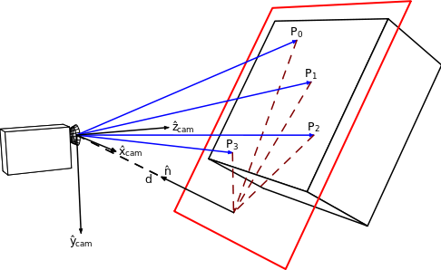

4 Points are needed for homography - 4 pairs (8 total points) - 8 dofs (degrees of freedom)

3 Points for affine - 3 pairs (6 total points) - 6 dofs

2 Points for similarity (translation, rotation, scaling) - 2 pairs (4 total) - 4 dofs

1 Point for translation - 1 pair (2 points total) - 2 dofs

* 1. Draw a picture that describes rectifying a plane – i.e. why you can convert the image a slanted plane such as the face of a building into an image of building as if you were viewing it head-on.

You can use a homography to perform this. When you map a set of points to a planar space the rest of the image will come along for the ride   
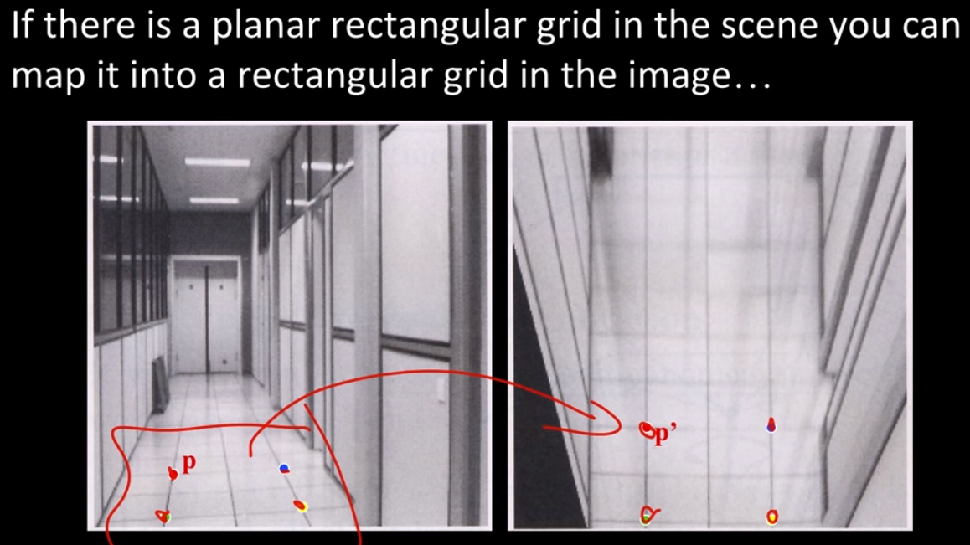

1. STEREO   
   1. Given two cameras and a point P in the world, draw out the epipolar plane geometry.

Baseline is the line from O to O’, Epipolar plane is the plane made by the lines from O to P, O’ to P, and the baseline. (Szeliski pg 348)  
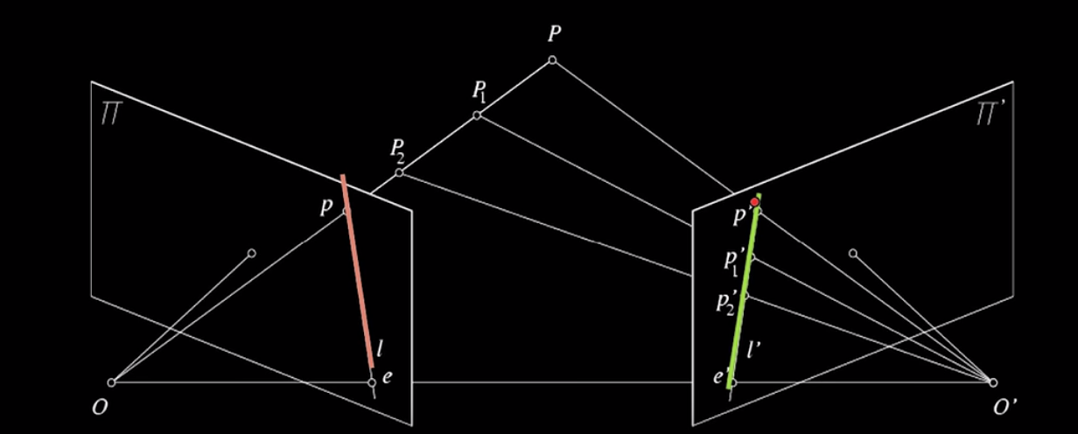

* 1. What is an epipole?   
     Intersection between the image plane and the baseline. Baseline is O to O’. e in both images is the epipole

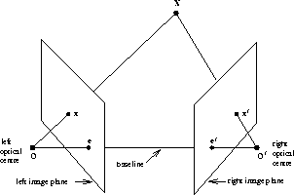

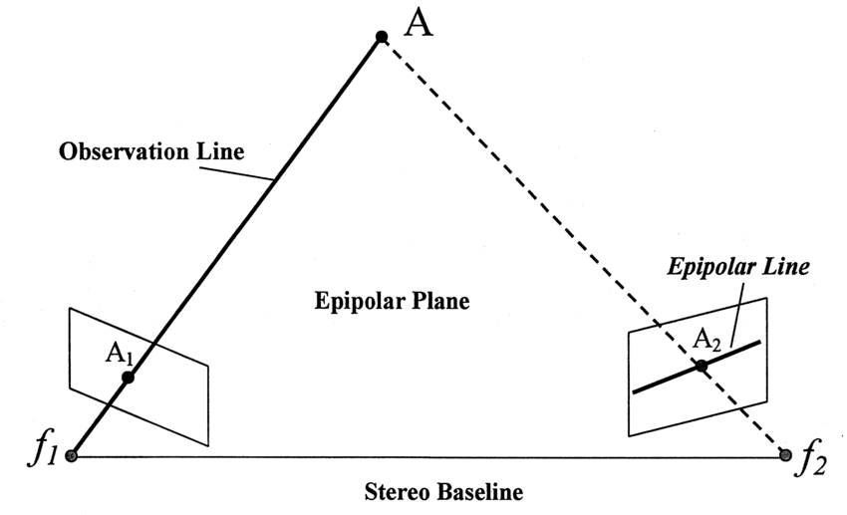

**Other definitions:**

* The **epipolar plane**: is the *plane* defined by a 3D point and the optical centres. Or, equivalently, by an image point and the optical centres.
* The **epipolar line**: is the *straight line* of intersection of the epipolar plane with the image plane. It is the image in one camera of a ray through the optical centre and image point in the other camera. All epipolar lines intersect at the epipole.
  1. What is the difference between the *essential* matrix and the *fundamental* matrix?

Both describe epipolar geometry between two views. The difference is that the fundamental matrix is described relative to the original image, whereas the essential matrix is normalized. In order to get the essential matrix you must know both the fundamental matrix and the camera’s intrinsics.

MORE on E: The essential matrix relates points from one calibrated camera frame to another. [X'^T]EX = 0. E is T x R - translate and rotate from X to X' frames. Since you know T and R (calibrated), you can construct E.

-Fundamental matrix associates a point to an epipolar line in the other camera’s frame (EXTRINSICS)

-Essential matrix associates a point in 1 image to a point in the other via transformation and rotation (INTRINSICS)

* 1. We view some world point P with two parallel cameras separated by baseline B meters, and with a focal length of *f.* If the world point P is located horizontally at xL in the left image (in the same units as *f*) and xR  in the right image the *disparity d* is (xL-xR). Write the formula for the depth *Z* of P in terms of *d,* B, and *f*.

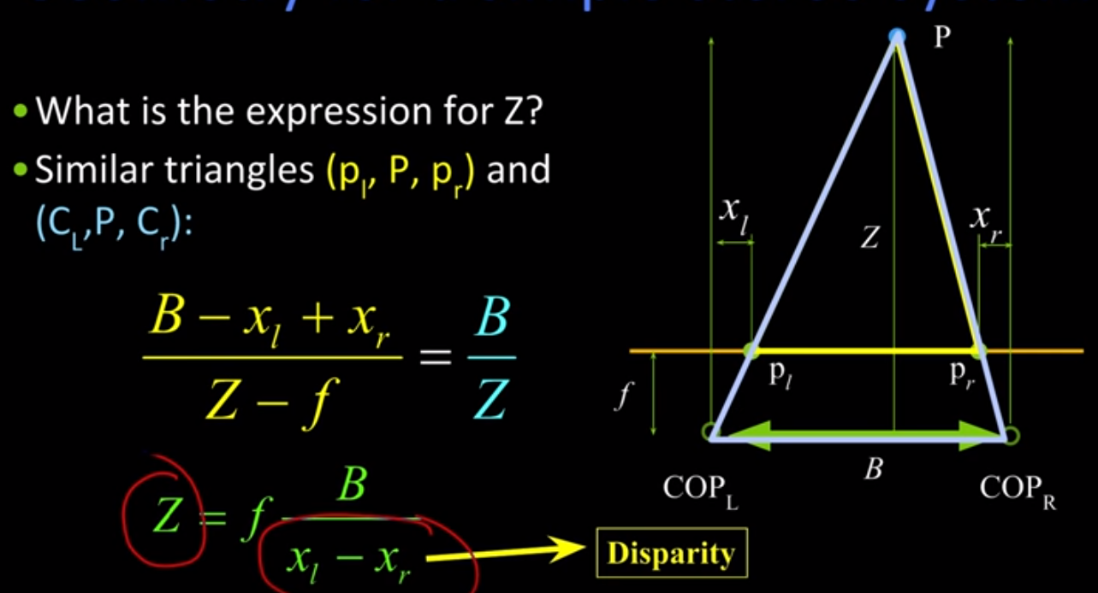

* 1. What are some constraints about the viewed surface or that matching that reduce the search in looking for stereo matches?  
     A point in one image has to lie on the epipolar line in the other. This is called the epipolar constraint, also soft constraints such as uniqueness and ordering.
  2. What’s the difference between normalized correlation and regular (cross) correlation?

Normalized correlation divides each sum of products by the total magnitude of the two areas. This keeps the result between 0.0 and 1.0, where the result is 1.0 if the regions are the exact same. OpenCV has an explanation here:

<https://docs.opencv.org/2.4/doc/tutorials/imgproc/histograms/template_matching/template_matching.html>

(Szeliski pg 387)

* 1. What does random dot stereograms tells us about human stereopsis?  
     -We recognize differences in depth via motion.

-We perform stereo stitching then depth detection on the resulting image

(Forsyth pgs 204-205)

1. SHADING  
   1. What is Lambertian shading? And what does it say is the relation between the incident light angle, the normal, the viewing direction and brightness?

Lambertian shading assumes body reflection only, no surface reflection (5A-L1: 25). This means that the object looks equally bright from all directions. The brightness you see when viewing only has to do with the albedo (constant) and your angle with the normal.

* 1. If a surface is Lambertian, how many known light sources would you need to turn on (one at a time) to unambiguously figure out the orientation of the surface at each visible point?

3 light sources (Source: The question below).

* 1. In photometric stereo under a Lambertian assumption there are 3 degrees of freedom at every point on the surface so we need at least 3 light sources. What are the 3 degrees of freedom? (Hint: two have to do with geometry.)

Based on the equation from 5A-L1: 30, the 3 degrees of freedom are surface normal, incident direction, and albedo.

1. FEATURES  
   1. We say that point descriptors should be both “invariant” and “distinctive”? What do we mean by “invariant” and why is it good?

Invariant means the point should not change due to scaling, orientation, illumination etc. Distinctive means we want a point that is unique and very unlikely to be misclassified/confused with some other region. Both of these features are ideal since this makes feature detection more robust.

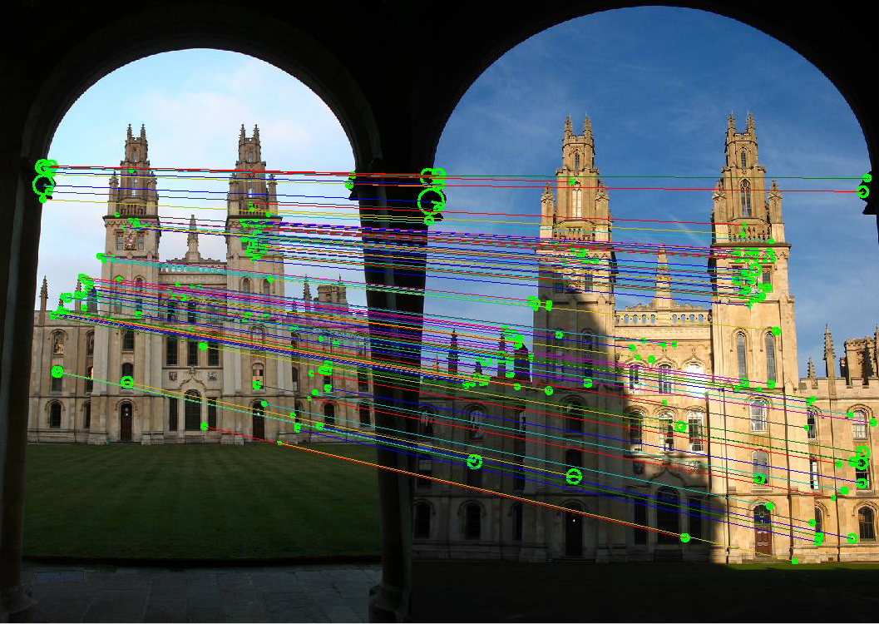

* 1. Harris features are referred to as “*Harris corners*” and are found by looking at a *2nd moment matrix.* Why and why? And what does it mean if the largest eigenvalues of that matrix is much, much, much bigger than the second one?

Harris features are called Harris corners since they extract corners in the image. The second moment matrix detects these corners by looking for strong gradients in the x and y directions. One eigenvalue being much larger than the other one is an edge (4A-L2: 32). If both eigenvalues are very large, it is a corner.

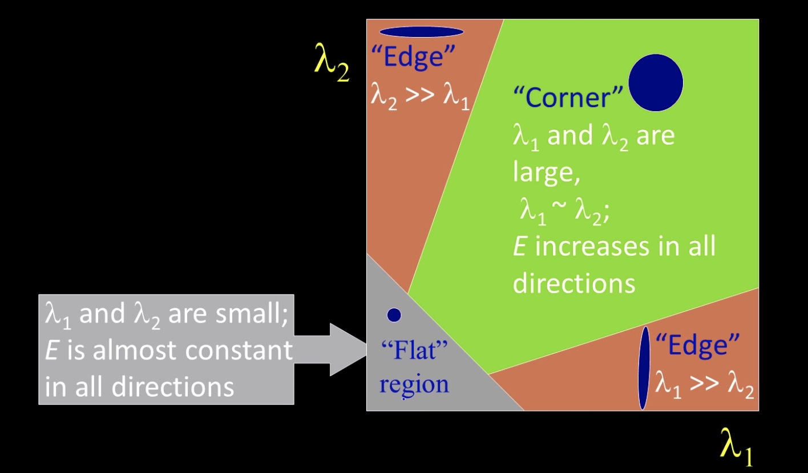

* 1. How can we make a feature detector (like SIFT) mostly invariant to illumination?

Clip the gradient magnitudes to reduce illumination effect? 4B-L1:28

**Yes, but he also claims that is better to normalize the image gradients to magnitude 1.0 (I guess 0.0, 1.0)**

* 1. Are Harris corners invariant to rotation? Why or why not? What about SIFT features?

**Harris corners** ARE invariant to **rotation** (imagine rotating a corner L -> _|, we can still positively id the corner). However, Harris corners are ***not* scale invariant**.

Harris corners are also mostly invariant to additive and multiplicative intensity changes (threshold issue for multiplicative). Since only derivatives are used they are also invariant to intensity shift; I = I+b.

SIFT -> (**Scale invariant f**eature transformation), and is **rotation and scale** invariant (See Lowe paper)

e. How are Lowe SIFT features and Harris-Laplacian features calculated?

SIFT (Lowe) features are calculated by finding the local maximum of difference of Gaussians in space and scale coordinates

Harris-Laplacian features are calculated by finding the local maximum of Harris corner detector in space (image coordinates) and apply Laplacian in scale

1. MODEL FITTING (4)  
   1. In using RANSAC to do, say, a panorama, what are putative matches? How do you get them? Why do you need them?

Putative matches are the “closest descriptors” to given set of features. They are found by searching for the best match between features using some metric/method (e.g. kd-tree, brute force, hashing). You need these matches to compute what the transformation is between the two images. Once you have that transformation - you can stitch the images together (4C-L1).

Use RANSAC to randomly pick points from your (putative matches) that will give you the best homography. RANSAC is a line fitting algorithm based on random sampling of the data.

* 1. Suppose we are using RANSAC to find circles. Our inputs might be points or oriented edge elements. What would the argument be as to why points are better? What would the argument be as to why the oriented edge elements would be better?

???Only link I could find: [quora question](https://www.quora.com/Suppose-we-are-using-RANSAC-to-find-circles-Would-you-rather-have-your-inputs-as-points-or-oriented-edge-elements-Why)

Points -> simpler and faster (edges requires more specific parameters)

Edges -> Work better with overlapping circles and images with lots of noise

SEGMENTATION

* 1. How can segmentation be thought of as a clustering problem? How do you get geometry into that approach?

Segmentation IS clustering (think K-means) in feature space. You are searching for densities that most match a certain color, descriptor etc. which fits the definition of clustering of unknowns. Geometry can be incorporated via euclidean distance or some other metric to convey label likelihood.

Instead of clustering in just the intensity space, we can also cluster in RGB space. Clustering is quantization of feature space and in order to apply this to the segmentation problem, we have to identify the feature space we do this in. So if you're doing a quantization in three dimensional space - Instead of just clustering on intensity, you would add the position as well.

* 1. What does Mean Shift do and how does it relate to segmentation?   
     Mean Shift is an iterative segmentation algorithm, that finds the “modes” (a.k.a. peaks) in the feature space. It allows us to do segmentation since it will find which mode each feature belongs to, thus grouping the features.

It is less sensitive to outliers than k-means.

1. MOTION  
   1. What is the Brightness constancy constraint equation and what are the unknowns?  
      Video: [6B-L1 Dense flow: Brightness constraint > 4. Optical Flow Constraints](https://youtu.be/-XXGrsFE4UI)  
      Assumes the pixel color/brightness (a.k.a. intensity) is the same after moving to some offset (u, v) at time t + 1 with u being movement in X direction and v in Y.   
      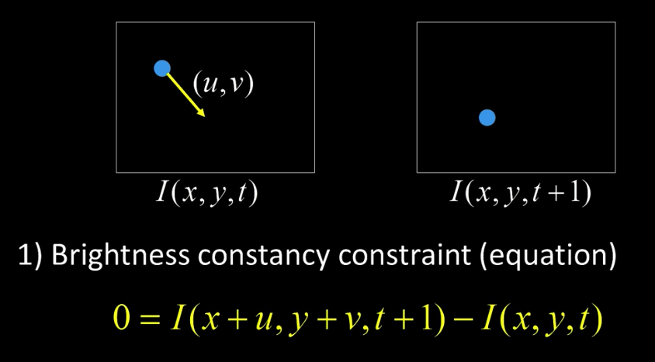
   2. What is the aperture problem in considering image motion?  
      Video: [6B-L1 Dense flow: Brightness constraint > 7. Aperture Problem](https://youtu.be/temtMhHER0Q?t=57)  
      You can only tell the motion locally in the direction perpendicular to the edge.  
      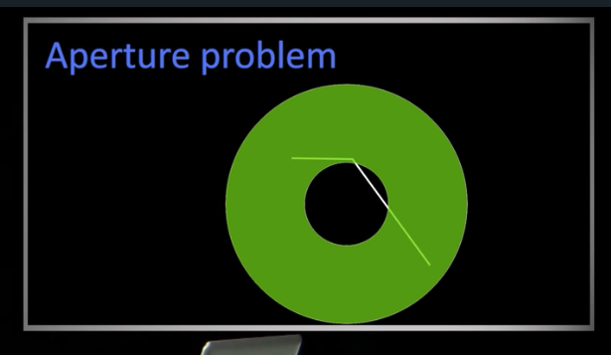

The brightness constraint equation assumes that there exists a pixel at time t+1 which has the same brightness of the pixel at time t shifted by a certain amount (u,v).

The problem is that for a single pixel we have two unknowns (u,v) but only a single equation (I_x*u + I_y*v + I_t = 0).

Hence, this becomes a minimization problem where we try to minimize the brightness constraint equation.  
One way to do this can be by changing the two unknowns for the whole image (Global constraint).

* 1. What is the relation between the Lucas and Kanade optical flow method and finding the Harris corners.  
     Video: [Lesson 39 > 3. Combining Local Constraints](https://youtu.be/kZ8iL0-fLc4?t=130)

In order to solve for the delta displacement in the two consecutive frames (u, v), we need to solve for the second moment matrix from the harris corner detector.

A transpose A is the second moment of the Harris detector. Look at the eigenvectors and eigenvalues of that matrix to know if something is a good corner.

-if Eig1 and Eig2 are large and about the same then we can tell the motion in this area, otherwise it is difficult to tell due to the aperture problem. Same was true for whether or not something was a good corner in harris corners.

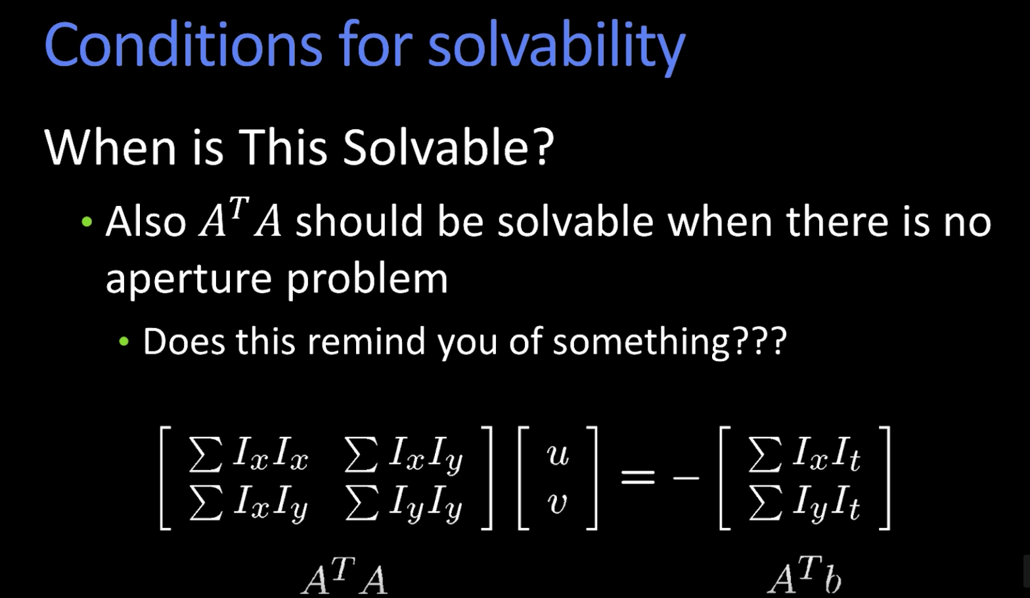

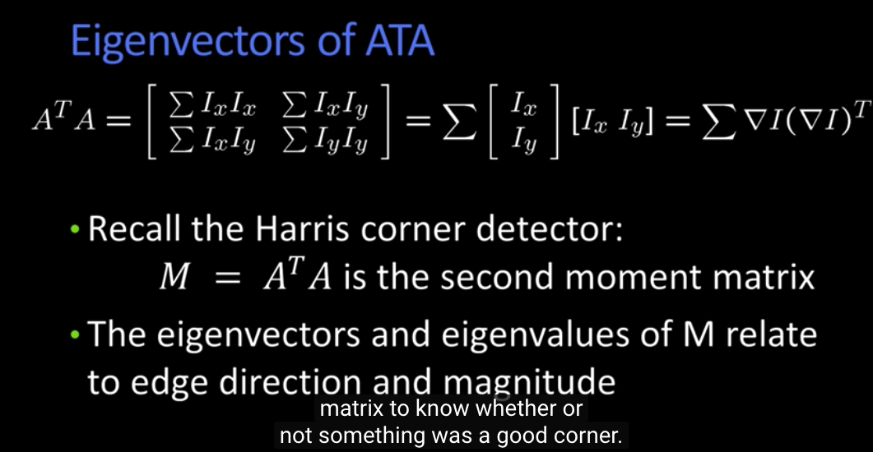

* 1. Lucas and Kanade is the optic flow method based upon gradients. What are the assumptions of the method? And what can be done to apply the algorithm when those assumptions are false.   
     Video: [Lesson 40 > 1. Intro](https://youtu.be/dVlRiJ-Xz8I?t=112)   
     1. Brightness constancy assumption: pixel hasn’t moved, didn’t change color, didn’t change intensity. When false solve via feature detection, such as SIFT  
     2. All points within a window move the same way and linearly. When false solve via motion segmentation. And coarse-to-fine estimation. <https://youtu.be/A8U8ydrnDms?t=60>

The assumption in the Taylor series expansion of LK is that the motion is very small (1 pixel). If this assumption is false, you need to downsample the image until the motion is small and then build it back up. This is what we did in Hierarchical LK!

* 1. How would you work the knowledge that there is affine flow only into the LK method?   
     [Lesson 41 > 8. Affine Motion](https://youtu.be/gK97vGePPuc?t=101) (hierarchical LK)

Substitute affine transformation equations into brightness constancy equation. This allows for a bigger window to test by allowing for non-linear movement (a.k.a. “flow”). Solve via least squares minimization with six unknowns.

1. TRACKING  
   1. Tracking is iterating between Prediction and Correction. In terms of the observations, prediction can be written as:  
      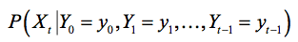  
      Write out a similar expression for the correction step.

For the correct step, we now know the current measurement (Y_t):

P(X_t | Y_0 = y_0, Y_1 = y_1, … , Y_(t-1) = y_(t-1), **Y_t = y_t)**

* 1. In such tracking what is the role of the dynamics model? The likelihood (observation) model?

The dynamics model is P(X_t | X_(t-1)). It is used in the prediction step (7B-L1: 18).

The observation model is P(y_t | X_t). It is used in the correction step (7B-L1: 19).

* 1. There are two independence (or conditional independence) assumptions in the tracking we did (Kalman or Particle). What are they? Hint – one has to do with the states, the other with the observations.

1. We assume the state is a Markov process - where the current state only depends on the previous state.
2. Observation: current observation is dependent on the current state only

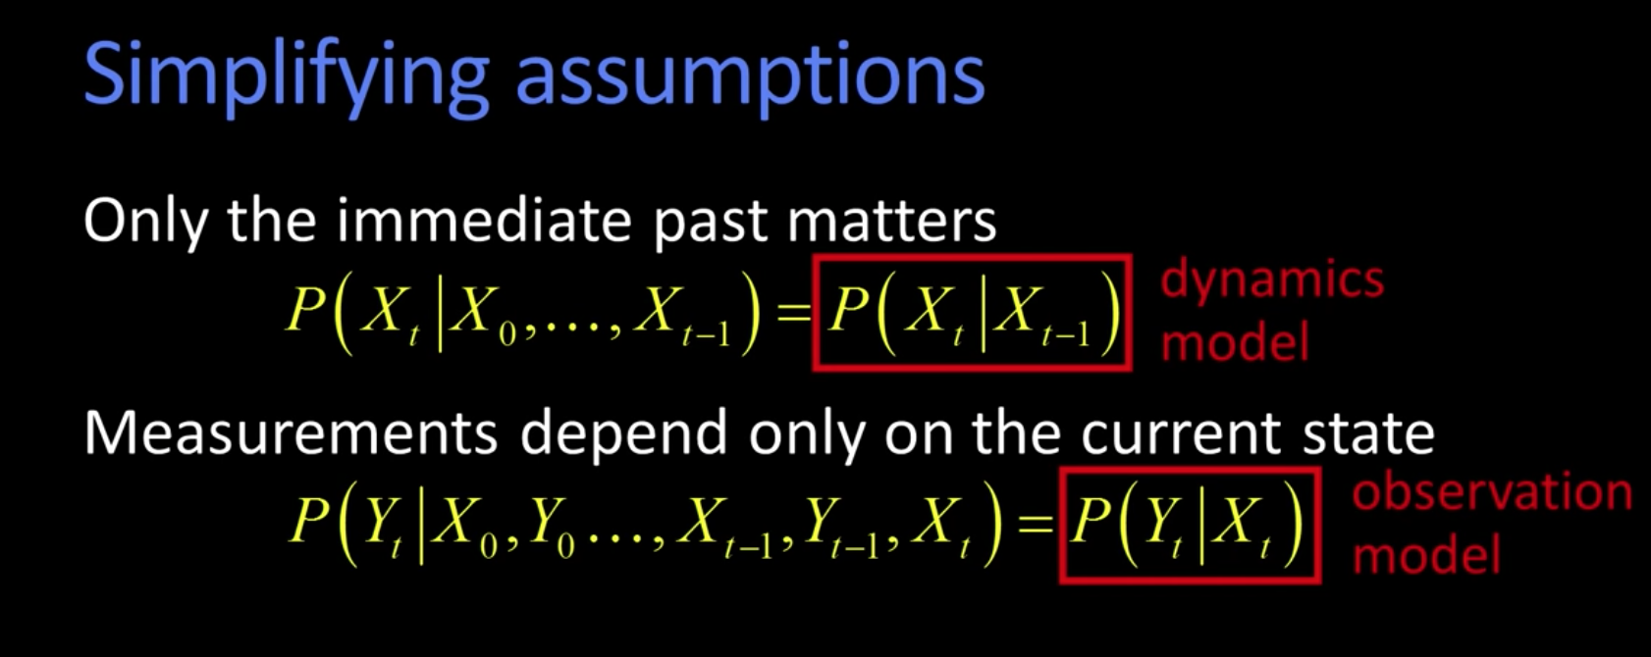

* 1. The Kalman filter imposes Gaussian distributions for the state estimation and two other model elements. What are those elements?

Process error Q and measurement error R. Although looking on Wikipedia it says that errors don’t need to be Gaussian in Kalman filter. Maybe in the version we studied they do?

-Dynamics model is the current state plus gaussian noise

-Measurement model is measurement plus gaussian noise

* 1. Particle filters first sample from a weighted distribution of particles, each particle being representative of the state. After that sample is picked, what is done to the sample ***before considering the measurements***

Apply the dynamics model (plus noise). Looking back at the assignment the steps were 1.) Normalize weights and resample 2.) Apply dynamics model 3.) Take the “measurement” using the template.

1. CLASSIFICATION  
   1. If we reduce the number of dimensions of a signal using PCA, we first subtract off the mean. Why?

Looking for **variation** about the mean. Dot product of u.T and (xi-mean). In general, there are M-1 eigenvectors. Subtracting the mean removes a degree of freedom.

We are trying to classify images, we want to remove the things that are shared between the images and only

From Wikipedia: if mean subtraction is not performed, the first principal component might instead correspond more or less to the mean of the data. A mean of zero is needed for finding a basis that minimizes the [mean square error](https://en.wikipedia.org/wiki/Minimum_mean_square_error) of the approximation of the data.

* 1. What’s the difference between generative models and discriminative models for classification? Which relies on Bayes rule and how?

Generative - builds model

of each class, compare all of them.

Discriminative - builds a model of the boundary between the classes.

Generative models can use Bayes rule to compare likelihoods: p(data / model of action i). If you have priors, you can use Bayes rule.

+

p(data | model) * p (model)

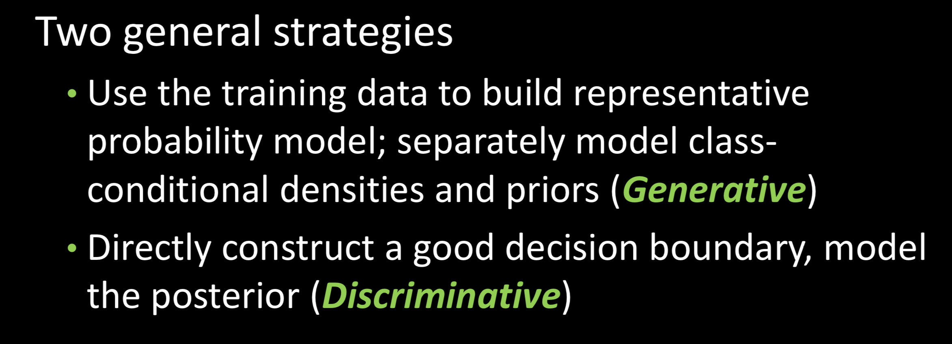  
<https://stats.stackexchange.com/questions/4689/generative-vs-discriminative-models-in-bayesian-context>

* 1. What’s a ***cascade (filter)***  and how is it used with boosting for face detection?

Used to reject negatives quickly.

Form a cascade with really low false negative rates early. Use the false positives from the first stage to feed into the next stage as ‘not a face’

* 1. What are integral images and why are they so useful?  
     Integral image is an image where each pixel value represents the rectangular area from the origin to that pixel. This is useful because...

Used in the Viola-Jones classification algo, integral images provide a way to perform quick (O(1)) summed area operations so we can use 4 points. The alternative would be O(N) where each pixel is summed both upwards and to the left, creating a large computation hit.

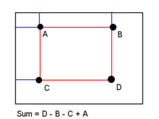

* 1. What is the ***Kernel trick***? And how do we make use of it with SVMs?

In nonlinear SVMs, you can use this kernel trick to provide a nonlinear decision 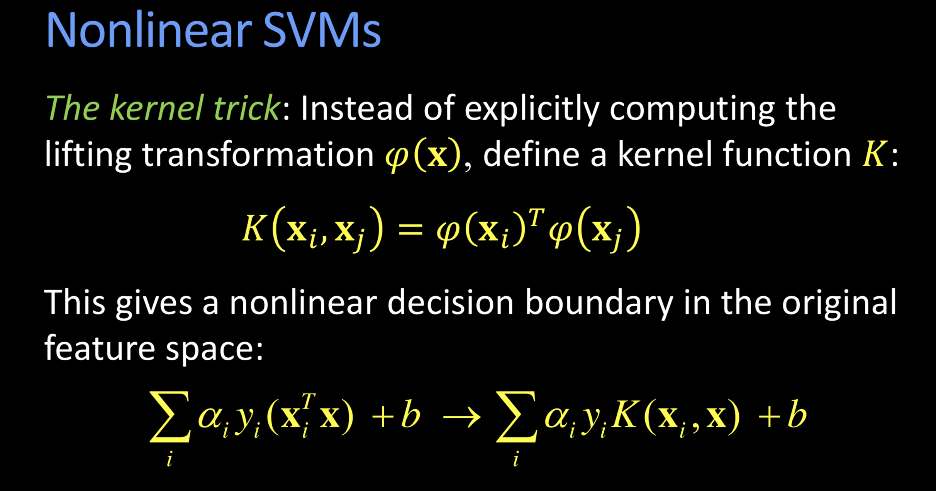boundary in the original feature space.

The kernel trick is that instead of explicitly computing the lifting transformation

(since it lifts us into a higher dimension ) φ(x), we instead define the kernel function

in a way that we know maps to a dot product in a higher dimensional space

* 1. How do we define the “bag of words” that is used for recognition?

The “bag of words” is a collection of patches from an image. By taking a new image and using a histogram to count the number of occurrences of each word we can “describe” or recognize the new image.

* 1. How many eigenvectors are there?

Subtracting out the mean yields M-1

1. ACTIVITY  
   1. An HMM is defined by a triple written in class as (A,B,𝚷) but in the book as (P,Q,𝚷) . What is each of these? (Or “What are the three elements that make up an HMM?” if you can’t remember which is which.)

A; the state transition probability matrix.

B; observation probability matrix (emission probability matrix)

Π: initial state distribution

* 1. What are the three fundamental problems to be solved when using an HMM? And what is the forward algorithm?

Evaluation P(O|lambda): Probability of occurrence of a particular sequence.

Decoding: Optimal state sequence to produce an observation sequence.

Learning: Determine model lambda, given training set of observations.

Forward recursive algorithm computes the likelihood of being in state i at time t, having observed the sequence from time 0 to time t.

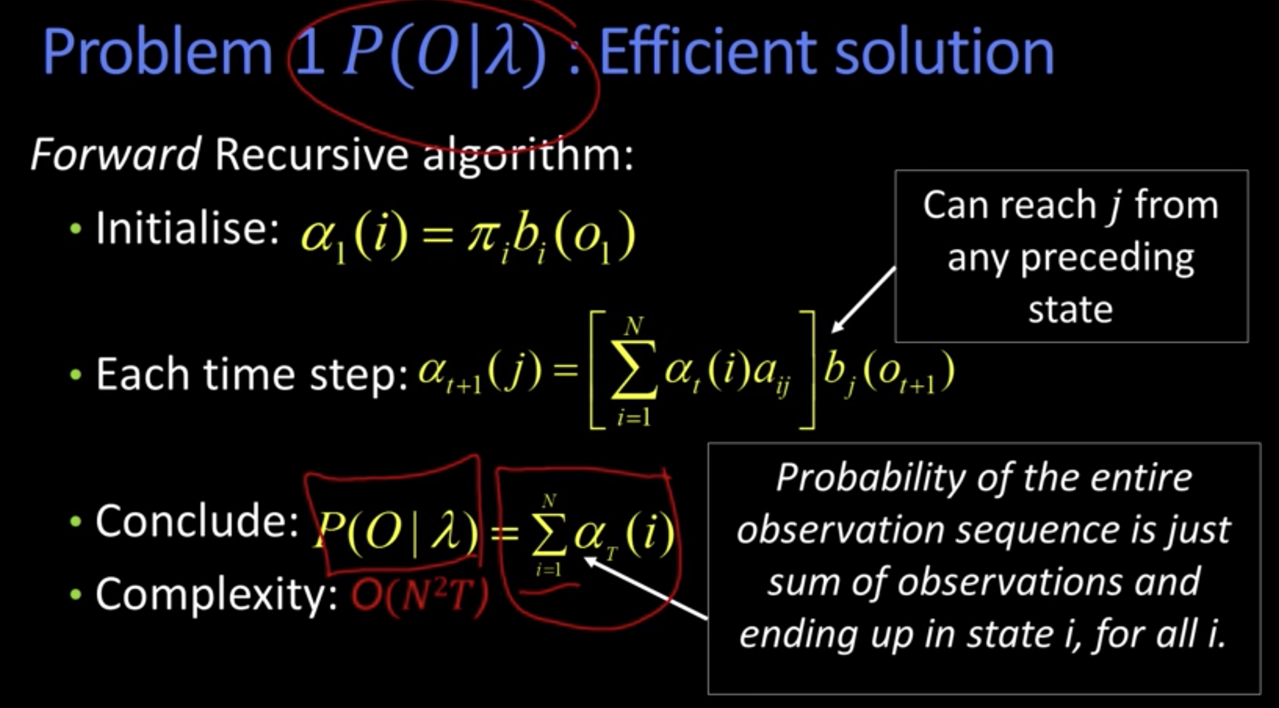

* 1. If N is the no. of states and T is the number of observations (one per time step), the forward algorithm gives a recursive method of computing the probability of a given HMM producing the observation sequence (written as P(O|𝞴) ). What is the computational complexity of that computation in terms of N and T?

O(N^2*T)

* 1. And just how are HMMs used in activity recognition?

HMM(Hidden markov models) have 3 steps to classify activities. At a high level they are generative models used in speech/activity recognition.

1. **Evaluation** -> What is the probability of observation sequence
2. **Decoding** -> What is the most likely way to reach this state
3. **Learning** -> Determine model M given training set observations used to maximize expectations

This answer is the same as (b)...maybe they are looking for specifics with regard to gesture recognition at the end of 8D-L3?

* For gesture recognition, e.g. hand gestures, sign language interpretation, etc.

1. MORPHOLOGY  
   1. How are OPEN and CLOSE defined in terms of Dilate and Erode?

Opening - operation of **erosion** followed by **dilation**. (Idempotent)

Closing - operation of **dilation** followed by **erosion. (**Idempotent**)**

* (external corners are preserved)  
  1. What is the effect of using a bigger structuring element when doing a CLOSE operation as opposed to a smaller one?

Using a large structuring element during closing will lead to thicker joints between regions. For instance in 9B-L1: 37, if the circle (structuring element) was super big - so big that it did not fit inside the valley between the peaks - that entire valley would be eliminated and the shape would be more like a trapezoid. Tiny structuring element would have almost effect since it maps to the original border very closely.

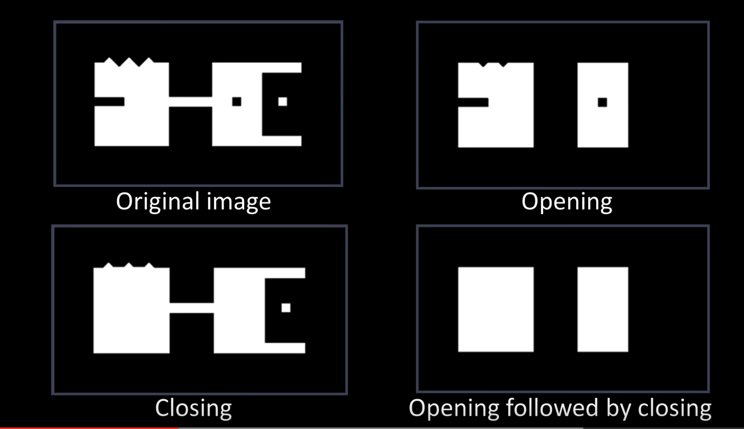

Note that the image below is just for erosion, when the question asks for CLOSE (which is dilation and then erosion).

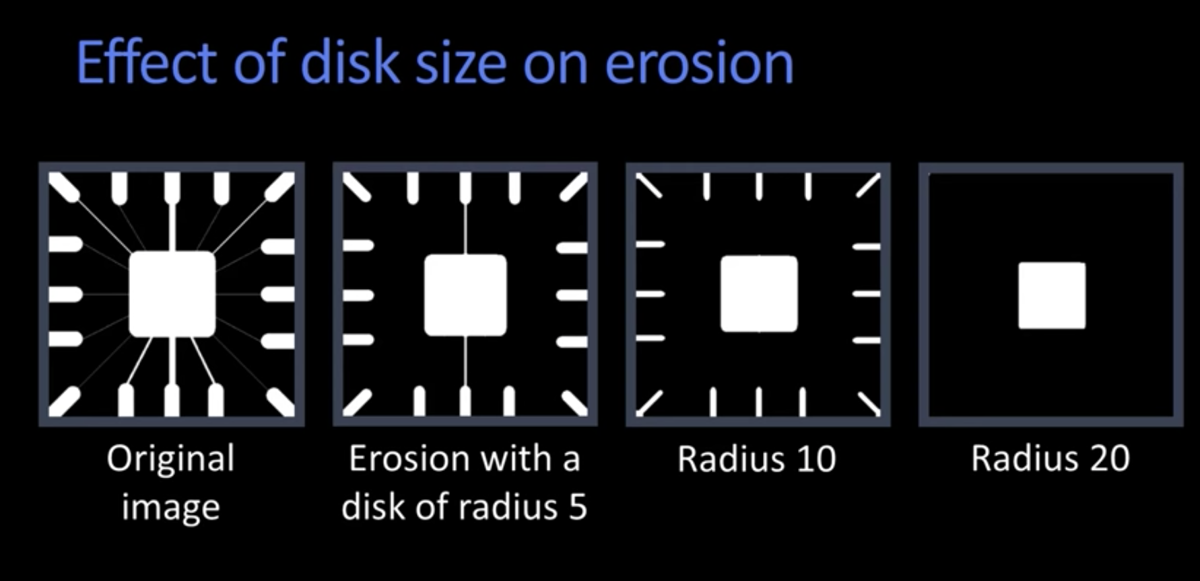

* 1. What is the maximum number of repeated CLOSE operations you can perform until you stop seeing any further effects?

1, Running the brush over and over again will result in the same result. (Idempotent)